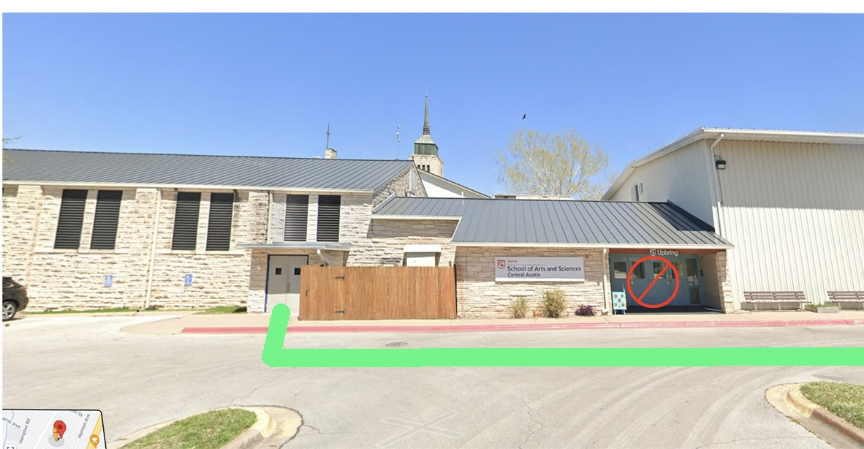Let’s Talk! Lutheran English Program

A Free Program for Adults whose first language is not American English

**In-person classes meet at St. Paul Lutheran Church/School, 3407 Red River, Austin, TX**

**Turn on Luther Lane. Free parking. You can also take the CapMetro Bus to St. Paul.**

**All classes meet one time each week.** To register or get the Zoom link for a class, please email: [**marcia@ulcaustin.com**](mailto:marcia@ulcaustin.com) **All times are listed in Central Daylight Time (GMT-05.00)** [**www.ulcaustin.com/ism**](http://www.ulcaustin.com/ism)

| **Sunday** | **Monday** | **Tuesday** | **Wednesday** | **Thursday** | **Friday** | **Saturday** |
| --- | --- | --- | --- | --- | --- | --- |
| **KEY**  **T = teacher** |  | **Class #1**  **9:00-10:15 AM**  **ESL Bible: Old Testament**  **Zoom & In-Person Teacher: Richard & Marcia**  ***Begins Aug. 26*** | **Class #3**  **10:30 - 12 Noon**  **Idioms & Slang**  **Zoom & In-Person**  **T: Richard**  ***Begins Aug. 27*** | **Class #6**  **7:00 - 8:00 AM**  **ESL Bible: Matthew**  **Zoom Only**  **T: Richard & Marcia**  ***Begins Aug. 28*** |  |  |
|  |  | **Class #2**  **10:45 AM -12 Noon**  **Conversation**  **Zoom & In-Person**  **T: Staff**  ***Begins Aug. 26*** | **Class #4**  **12:30 – 1:30 PM**  **ESL Bible Matthew**  **Zoom & In-Person**  **T: Richard & Marcia**  ***Begins Aug. 27*** |  |  |  |
|  |  |  | **Class #5**  **1:00-4:00PM**  **Water Color Painting Group**  **In-Person Only**  **Host: Betty**  **Meets each week** |  |  | **Class #10**  **7:00 - 8:00PM**  **ESL Bible**  Various Topics  **Zoom Only**  **T: Rev. Al**  **Meets each week** |

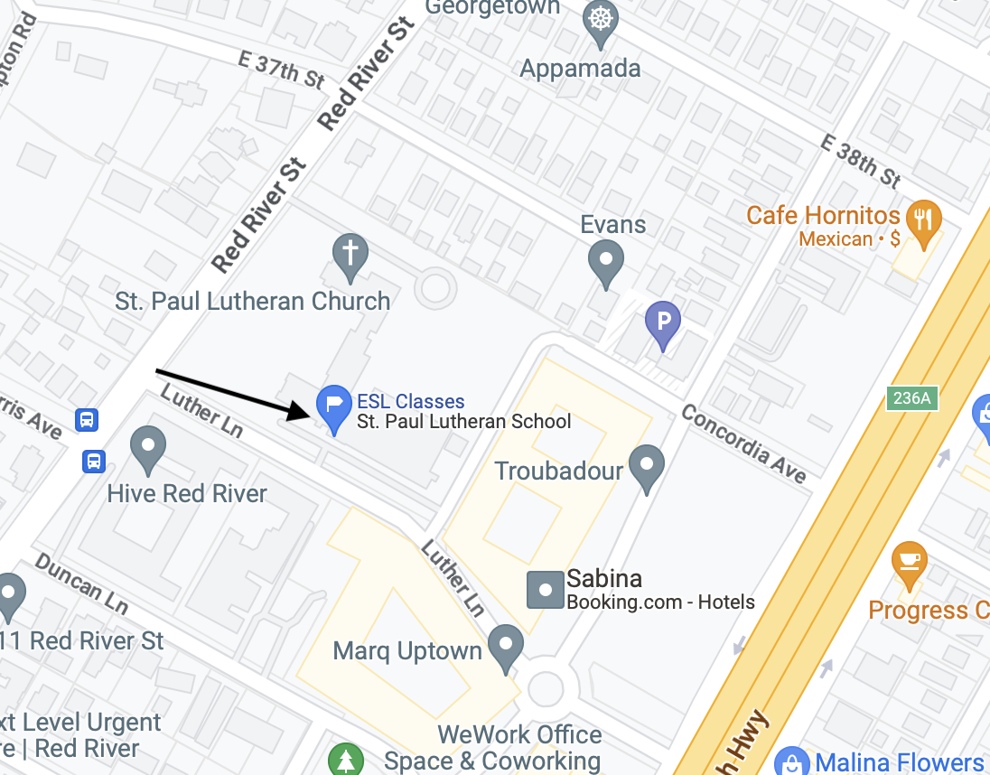**Class Descriptions\***

**In-person classes meet at St. Paul Lutheran School, 3407 Red River, Austin, TX,78705. Turn on Luther Lane.**

**To register and to receive the Zoom Link for online classes, please email Mrs. Marcia Mittwede:** [**Marcia@ulcaustin.com**](mailto:Marcia@ulcaustin.com)

**English Conversation:** Students practice speaking English in a casual setting in a group of 3 – 6 people. Worksheets are provided on topics related to life today.

**ESL Bible Class (offered at various times)**

This ancient book has inspired much language in American culture. English Bibles are provided free-of-charge for participants. No Bible knowledge necessary.

**Idioms and Slang** The American language uses many idioms and much slang.  This class will help define idioms and slang expressions that are common in every-day life in America today.

**Pronunciation** Students receive instruction and practice in pronouncing words that are difficult for them. (Class is not currently meeting.)

**Water Color Painting:** Students meet together to paint on their own and practice water color painting. This class does not instruct you in how to use water color paints, but there is an experienced art teacher who will give you tips on how to make your paintings better.

**\**Speaking* American English is the emphasis of this program.** To get the most out of classes, students should be able to ask and answer basic questions in English and follow instructions in English. While every level of English-speaking person is welcome to *try* the classes, a person whose English is at least at an Intermediate level will benefit most from this program.

**Rev. Richard Mittwede, Campus Pastor** [**richard@ulcaustin.com**](mailto:richard@ulcaustin.com) **512-461-3425 (cell)**

**Mrs. Marcia Mittwede, Director/Lutheran English Program,** [**marcia@ulcaustin.com**](mailto:marcia@ulcaustin.com) **512-660-8440 (cell)**